Alzheimer Scotland – Business Lunch Aberdeen
An introduction to Alzheimer Scotland
Alzheimer Scotland is Scotland’s national dementia charity; our aim is simple; to make sure nobody faces dementia alone. We provide support and information to people with dementia, their carers, and families, we campaign for the rights of people with dementia and fund vital dementia research.
The Business Lunch will provide a space to engage with like minded businesses, to hear from engaging speakers, Anne McWhinne, Gail Dolan and Neil Fullerton who will showcase our work and how your business can become a dementia friendly employer and enhance your companies image in Scotland.
Remarkable Partnerships across our community
There are many way we can create partnerships together, with the business community, it can include working with you and your teams to meet your CSR objectives, work with you to identify a culturally personalised business approach to; raising funds, develop engaging events, provide volunteering opportunities, award winning employee engagement programmes, create PR opportunities and deliver dementia friend sessions enabling your business to improve lives of customers, suppliers, employees and your own families and friends.
We will always be happy to discuss ideas with you
Benefits to you and your organisation:
The key benefits of being associated as a partner with Alzheimer Scotland vary, but can include:
- An opportunity to give back to the community; a chance to improve others’ lives
- A chance to network with other community spirited businesspeople
- Good PR and networking opportunities
- Stress reduction, helping others is known to be a great way to reduce stress and improve productivity and improve employee engagement
- Learning and personal development, we are learning more about dementia and you will be at the front with us
- Enhanced CSR position
- Improved practices to support a dementia friendly community
- Have a dedicated member of our Stakeholder Engagement team to work with in a meaningful and supportive capacity to develop the relationship into a position where we build personalised solutions into the partnership.

What we do and how we do it
Data tells us that numbers are set to rise and we know that Alzheimer Scotland’s role is increasingly vital to Scotland’s communities providing emotional, social, and practical support to ensure people who are living with the disease live as independently and as well as possible, for as long as possible.
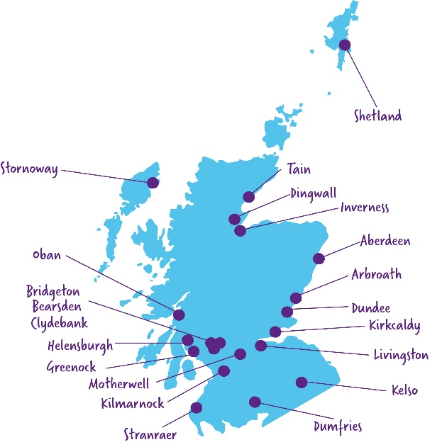
Dementia Resource Centres our Dementia Resource Centres are in 21 different places across Scotland. We have an extensive reach across the Glasgow Health Board area with a dementia resource centre (DRC) in Bridgeton Glasgow, Bearsden, and Clydebank
The centres provide a safe and friendly environment for people with dementia and their carers to visit and take part in a wide variety of activity groups.
There is a network of 36 Dementia Advisors employed by Alzheimer Scotland who work in local communities to support people with a diagnosis by giving advice and information, and delivering online and face-to-face support.

We are very proud of our 24 hour 365 Freephone Dementia Helpline which provides information and emotional support to people with dementia, carers, families, friends and professionals.
In partnership with the NHS and Scottish Government we have a team of twelve Alzheimer Scotland Dementia Nurse Consultants (ASDNC) embedded in every NHS board across Scotland to improve the experience of people living with dementia who are admitted to hospital Alzheimer Scotland Dementia Nurse Consultants In addition to the amazing ASDNC’s we have 10,000 dementia champions trained to deliver skilled dementia care. In response to the impact of Covid 19 an Action on Rights team was set up to support the visitation rights of families supporting as person within a care home. To support our colleagues, we have introduced a Counselling Service to ensure our staffs’ mental health and wellbeing are supported internally.

Impact and breadth of our work:
- Our 36 Dementia Advisors cover 493 miles from Shetland to Stranraer
- We have committed £7million to our network of Dementia Advisors
- For thirty years we have provided a 24/7 365 day a year free helpline
- 50% of all calls to our helpline are from people needing emotional support
- Almost 75% of calls are from a carer, friend or relative of someone living with dementia
- Alzheimer Scotland Dementia Nurse Consultants are transforming specialist dementia hospital care
- Every month we support over 600 people with dementia – 13% are under the age of 65
- Looking to the future our mission is to inspire and empower everyone in Scotland to protect their brain health and reduce their risk of diseases that lead to dementia Brain Health Scotland
- Campaigning and giving a voice to people and their carers living with dementia Campaign for change
What people tell us matters to them about Alzheimer Scotland
“I can’t express how much help it was to have you there; someone to ask questions regarding the illness. The role was also emotionally supporting me during the time I was caring for my mum and since she has passed away. It’s such an isolating illness and without you I would’ve struggled to cope, then and now.”

“It’s great to be able to talk to people in the same situation as you and share the load. I can’t imagine doing this alone.”

“This has been the hardest year ever losing my husband, but you’ve been there all the way through, can’t thank you enough’

 Cost of dementia
It is estimated that 10% of people diagnosed in Scotland with dementia are living in the Glasgow area.
Research shows there are about 8,000 people living in Glasgow with dementia, extrapolate that number to include the families and carers who are impacted daily and that is a conservative 40,000 lives affected here in Glasgow. Every person affected by dementia is potentially a customer, an employee a family member.
In addition to the emotional cost of dementia there is a financial and practical cost to our communities and businesses. Data isn’t clear however it is estimated there are c 93,00 people living with dementia across Scotland which equates to 1.5% of the population. That number increases dramatically If we consider the families and loved ones who are also impacted, we can easily add another (conservative) five people, e.g. a spouse, two children and 2 grandchildren and we are looking at an additional 465,000 people or 9% of the population who are living with dementia across Scotland. The impact of dementia affects all of us, families, businesses, healthcare providers and the community.
Dementia not only devastates lives; it is a significant cost to the economy. The cost of dementia care is spread across three main sectors, with most costs falling on informal carers.
- Healthcare: these costs mainly fall on the NHS and are due to hospitalisation of people living with dementia, which can be due to a variety of causes.
- Social care: relates to the cost of services such as care and nursing homes, homecare, and respite care.
- Informal care: relates to the family and friends providing unpaid care for people living with dementia
The financial cost of dementia in the UK is expected to more than double in the next 25 years, from £26bn to £55bn in 2040

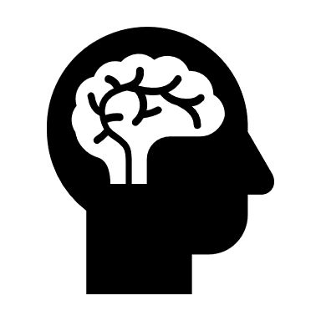What is dementia
DEMENTIA IS NOT A NATURAL PART OF THE AGEING PROCESS. It’s caused by diseases that affect the brain.
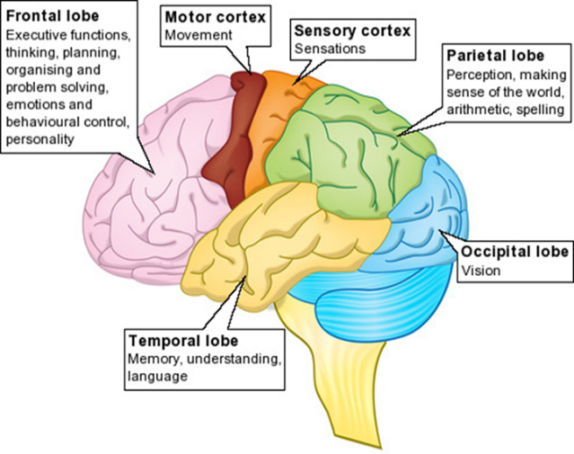
Dementia is an umbrella term for over 100 different types of diseases and symptoms. It is possible to have more than one type of dementia
What all these diseases have in common is they damage brain cells, so that the brain cannot work as well as it should.
Dementia can affect every area of human thinking, feeling and behaviour, each person with dementia is different

Working together we can help to make the Aberdeen a dementia friendly community for the benefit of all

